A little bit about software...
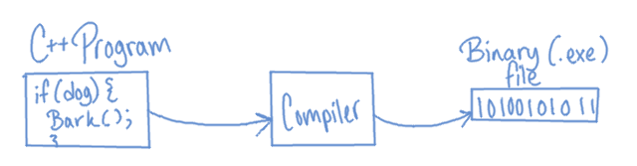
Most programming languages get compiled from the language (ie, C++) to machine code (Binary). Compiling is the process where the human-readable C++ code is “translated” to something the computer can read and work with (a .exe file in Windows).

Compiling is specific to a certain type of architecture, so something you build on Windows won't run on OSX or Linux unless you re-compile it for that platform.

There are also scripting languages, like Python. These work differently than compiled languages in that, rather than being compiled into machine code, the Python script runs in the Python program. A computer just needs to install Python itself, and then it can run your Python scripts without any (or much) tweaking for a specific operating system.
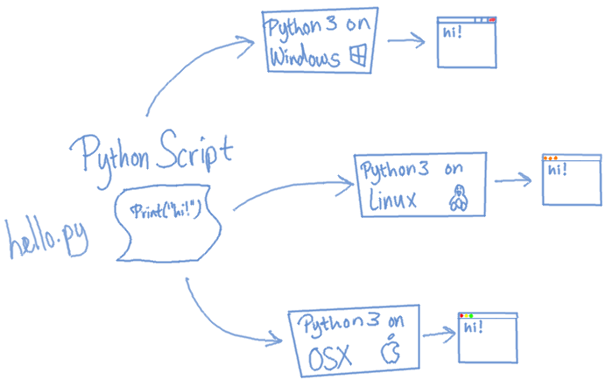

An IDE (“Integrated Development Environment”) is a software tool. It allows you to write your code, usually provides debugging and project management tools, and contains a compiler that will compile your C++ program into a binary file (aka an executable or .exe file, on Windows). An IDE is NOT the compiler, but it usually is hooked up to a compiler so you can build your project from the IDE!
IDLE is an example of a Python IDE, even though it doesn't compile Python.

You don't need an IDE to build C++ code into executables, you can write your programs in a text editor (like Notepad++) and then build them directly through the compiler (like g++), but we're going to use an IDE for this class. You can use whatever you're comfortable with. :)

Setting up your Integrated Development Environment
The computers in UMKC's lab run Visual Studio 2010. If you've activated your student MSDN account, you can go to Microsoft's website and download a student edition of Visual Studio 2010 for your own computer.
However, C++ is C++ is C++ no matter what IDE you choose to use, so there are some alternatives, as well!
All of these IDEs have debugging tools, and much more!

Visual C++ Express (http://www.microsoft.com/visualstudio/eng/products/visual-studio-express-products) is available to everybody for free.

Code::Blocks (http://www.codeblocks.org/) is an open source IDE that is also available for free. It is available for Windows, Linux, and OSX, and it is my preferred IDE.

Eclipse (http://www.eclipse.org/downloads/packages/eclipse-ide-cc-developers/junosr2) is more widely known as a Java IDE, but there is also a version of Eclipse for C++ development. It is free and also available on Windows, Linux, and OSX.

Xcode (https://developer.apple.com/xcode/) is Apple's IDE. I don't know how to use it, since I don't have an OSX machine. You'll have to Google how to debug and such. I think it costs something like $5 to download.

Source Control
Throughout school, it will be handy for you to back up your work at regular intervals and store it online, incase your computer ever dies, you break something in your code and aren't sure what, and to have it for future reference and accessible from all of your machines.
Source Control is a tool for keeping track of changes made in your code, storing your code in a safe place, and also providing you the ability to collaborate with others without overwriting each others' work.
Source Control is heavily used in the professional software development world, and once you get the hang of it you will never want to write a single line of code without source control ever again. (At least, I certainly don't!)

Please watch my “Intro to Source Control” video before continuing:
http://www.youtube.com/watch?v=K0mgc3efx-A

If you haven't noticed already, the class “website” is really just a Git repository on the GitHub hosting website!

GitHub
We are going to use the Git source control solution in this class, hosted on the GitHub website. We are going to use this because GitHub provides “GitHub for Windows” and “GitHub for Mac”, which gives you a really easy user interface for using Git.

GitHub gives free project hosting for Open Source projects, though they charge for private hosting. However, with your student email, you can get a free private repo on GitHub.

- Register for a student account
https://github.com/edu
- Download the GitHub client
  - Windows: http://windows.github.com/
  - Mac: http://mac.github.com/
  - Linux: If you're running Linux, it's assumed that you're adept enough with technical things to use Git from the command line or a Linux UI Git client. :)
- Create a “CS201” repository
A Repository is where your code is stored on the GitHub server. You can create as many repositories as you want for different projects.
You can create a new repo either on the GitHub.com page, or through the client. From the client, click “+ add” and name the repository “CS201”.
Make sure you check “Push to github” and “Keep this code private”, then click “Create”.

- Share your “CS201” repository with me
- Right-click your repository in the GitHub client. Click “view on github”.
- On the repository's GitHub page, select Settings.
- Click on the left Collaborators tab.
- Under Manage Collaborators, highlight the “Add a friend” textbox and type “Moosader”, then click Add.

With your CS201 repository shared with me, I will be able to more easily help you if you get stuck, and you won't have to manually submit your project to me when it's due – Just make sure it's done before the due date & time and I'll handle the rest.

Commit your first file
There should be a local copy of your repository on your computer; it was a field you set when creating the repository. Navigate there in Windows Explorer (or what-have-you).

- Create a new folder inside of your repository directory: “Week01”.
- Open the Week01 folder and create a new text file: “test.txt”. Add some text to it, save, and close.
- Open up the GitHub client and select your CS201 repository. It should show that changes have been made in the repository folder. It will be expecting some comments about them.
- Enter a title for this set of changes you've made (it can be “adding test file”, but this could be something like “file is loading and being read into program” so it's easy to find later). You can also add additional comments if you have more notes that might be important for these changes.
- Click on the “commit” button. You will then see a list of unsynced commits.
Creating a commit does not automatically push your changes to the web server on GitHub; they are still local only to your computer, and if your computer dies, then these changes will be lost.
You can make as many commits as you want before pushing to the GitHub server. Each commit serves as a “snapshot” backup of your code, so make sure you commit after you get a feature working!
- To push our changes to the server, click on the “sync” button to the right of the repository name. Once it's finished syncing with the GitHub server, you can view your repository on GitHub.com. The Week01 folder and the test.txt file will be viewable.

Other GitHub features
On your repository's GitHub page, there is a line of buttons across the top reading: Code, Network, Pull Requests, Issues, Wiki, Graphs, and Settings.

Code | On this tab, you can view the files that have been committed to the GitHub servers under the Files tab.  Under Commits, you can view a list of changes you have committed in the past and you can compare a file between two different commits.
Issues | This is a place where you can keep track of bugs, if you choose. I usually use this area as a “To-do list” and make tickets for different features in a program I need to add.
Wiki | Here you can add pages to a Wiki if you need to. These can be design notes or anything else you might need.

